Christopher Feldman

Spring Semester 2020

Reverse Engineering a Target Blade with T-Blade3 Parameters

The goal of this project was to develop a method of inputting an airfoil and retrieving the T-Blade3 inputs required to recreate it. OpenMDAO was used as the optimizer and the objective function being minimized was the sum of the square distances between the target airfoil and the airfoil generated by T-Blade3. The optimizer iterated over thickness and camber inputs including: max thickness, in and out beta angles, location of max thickness, trailing edge thickness, trailing edge slope dy_dx_TE, leading edge radius, and camber curvature control points. The airfoils are split into leading edge, trailing edge, top, and bottom sections. When looking at the blade generated by T-Blade3, for LE and TE, u is found as a function of v; for the Top and Bottom, v is found as a function of u. The square distance is then found between the points target airfoil and their corresponding points on the linear interpolations along the blade generated by T-Blade3. The distances are then summed to make the sum of least square distances.

The reverse engineering process is functional and works on both NACA series airfoils and other series.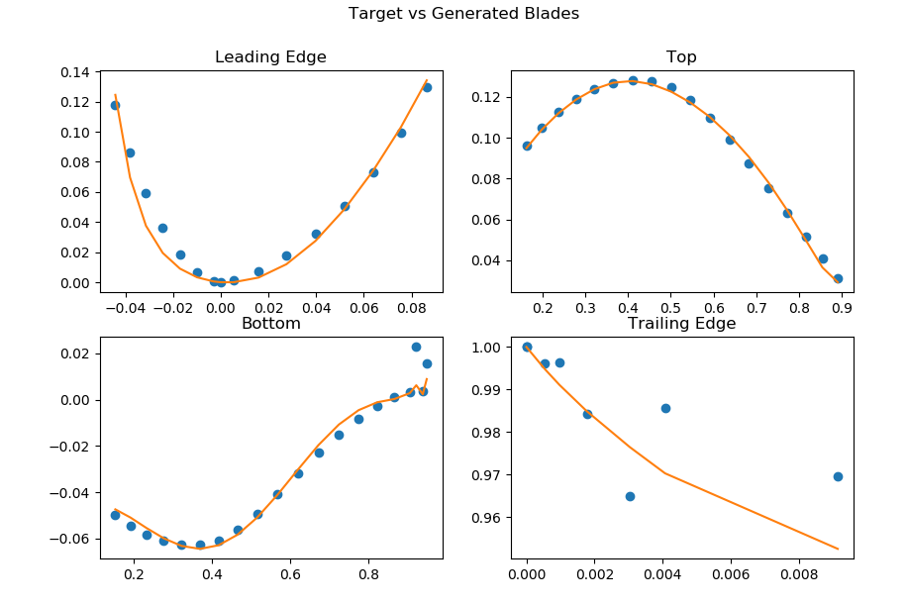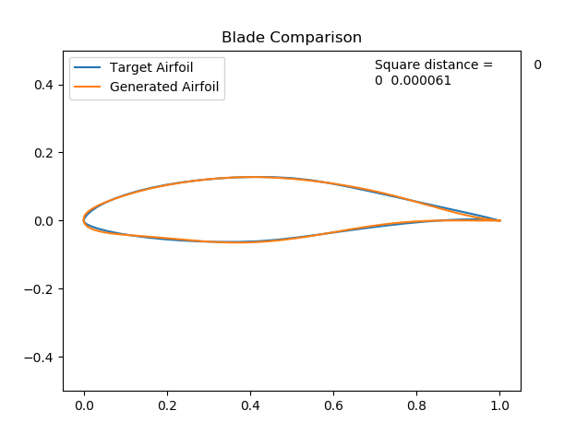

Eppler 1098